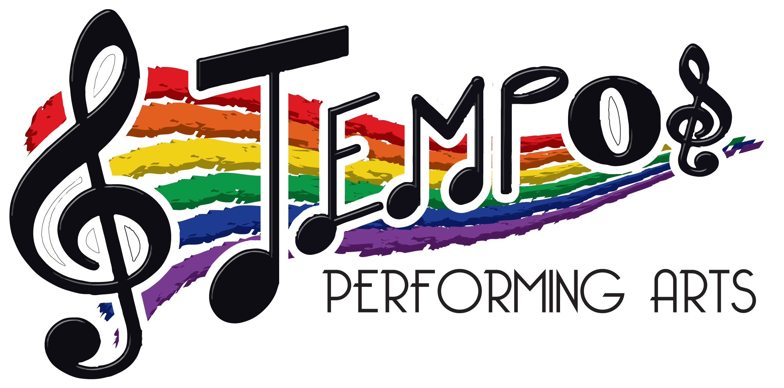 PERSONALISED UNIFORM

All Personalised Orders will be placed with our suppliers on 1st or 15th of the month and take up to 2 weeks to arrive after this date.
( if you email your order to us on 2nd then your order will not be sent until 15th)

We recommend that you ONLY HAND WASH your TPA uniform to avoid colours fading and damage to delicate fabrics.

CLASS | ITEM DESCRIPTION | PRICE | Size options
All Musical Theatre, Street Dance & Show Choir Classes  * Required  All Senior Musical Theatre, Street Dance, Show choir students (additional choice) | Personalised TPA t shirt  Available in Pink, Red, Blue, Green, Orange or Yellow.  Personalised TPA Racer Back Vest  Available in Pink, Red, green, purple, blue, yellow, neon pink, neon green, neon orange, neon yellow | £15  £15 | Age 3 /4, 5/6, 7/8, 9/11  12/13  ADULT XS, S, M, L, XL#  Age 12/13  ADULT XS, S, M, L, XL, XXL
All Musical Theatre, Street Dance & Show Choir Classes  *Required  Optional for all other classes  All Inter/Senior Musical Theatre, Street Dance, Show choir students (additional choice)  Optional for All other Inter/Senior students.  All Classes  Optional for All Students – perfect for Street, MT and Show Choir students | Personalised TPA zipped hoodie (ZOODIE)  Available in: pink, blue, red, green, yellow or purple  Personalised TPA Neon Hoodie  Available in Green, Orange, Pink or Yellow  TPA Joggers  Available in Black with #TPAfamily and logo | £25 Child  £30 Adult  £25 Child  £30 Adult  £22.50 | Age 3 /4, 5/6, 7/8, 9/11  12/13  ADULT XS, S, M, L, XL  Age 7/8, 9/11. 12/13  ADULT S, M, L, XL, XXL  Age 3-4, 5-6, 7-8, 9-11 & 12-13 years or adult XS, S, M, L & XL
All Classes  Optional for All Students – perfect for Acro/Ballet students for warm up and travelling to and from classes. | Personalised TPA Onesie  Available in Pink, Red, Purple Green Blue (child sizes)  Pink/Black (Adult Sizes) | £38 Child  £42 Adult | Age 3 /4, 5/6, 7/8, 9/10  11/12, 13/15  ADULT XS, S/M, L/XL
All Classes  Optional for All Students. | Personalised TPA Plastic Infuser Water Bottle  Available in PINK, GREEN, BLUE & PURPLE | £10 | N/A
All Classes  Optional for All Students.  All Classes  Optional for All Students. | Personalised TPA Metal “Chilly” Bottle  Available in Pastel PINK, Pastel BLUE & TURQUOISE  Personalised TPA Barrell Bag  Available in Black/Pink or Black | £15  £22 | N/A  N/A
All Classes  Optional for All Students. | Personalised TPA reversible Sequin Bag bn with inside pocket and luxury velour back  Available in Pink, Blue, Gold, Silver, Black and Rose Gold | £20 | N/A

